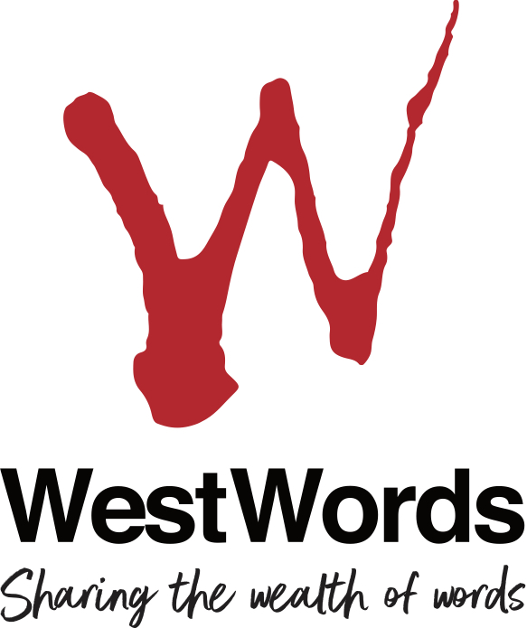

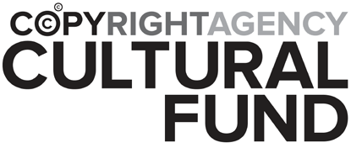

Copyright Agency/WestWords
Western Sydney Emerging Writers’ Fellowships

Guidelines for Applicants

For more information please contact:
Michael Campbell
Executive Director, WestWords
E: michael@westwords.com.au
T: 02 8677 4815
CA WestWords Western Sydney Emerging Writers’ Fellowships
Guidelines for Applicants
The CA WestWords Western Sydney Emerging Writers’ Fellowships offers 3 Fellowships of $4,000 each to emerging writers aged 16 years and over from the Greater Western Sydney region.

DESCRIPTION

The Fellowships support the artistic development of creators of literature from Greater Western Sydney to fulfil the following objectives:

- to provide professional development and income to writers from Greater Western Sydney
- to strengthen the professional writing community in western Sydney
- to support literature development and appreciation among young people in western Sydney
- to engage the young people of western Sydney in cultural activity around books and writing.

There are three parts to each Fellowship:

- Development of your work as a writer
- Mentorship opportunities
- Working with young people in western Sydney

1. Development of your work as a writer:
The purpose of the Fellowship is to provide income support to emerging writers to allow them time and space to develop a particular writing project.

2. Mentorship opportunities
The CA WestWords Western Emerging Sydney Writers’ Fellowships provides successful applicants with the opportunity to be mentored by an established and experienced writer. This may include manuscript assessment and development, guidance in the design and delivery of the workshop component of the Fellowship, or any other aspect of professional development that the Fellow wishes to pursue. This component of the Fellowship will be developed in consultation with the Fellow and WestWords staff.

3. Working with young people
Each successful applicant will be required, as part of the terms of agreement of their Fellowship, to deliver a creative program with and for young people in Greater Western Sydney. This program will be roughly the equivalent of 1 day of workshops. This workshop program will be developed in consultation with WestWords staff and, where relevant, the Fellow’s Mentor.

WHO SHOULD APPLY?

The Fellowships are open to emerging writers* working in genres including fiction, non-fiction, journalism, poetry and song lyrics, writing for performance, writing for online or new media and other forms of creative writing. Illustrators and graphic designers with a demonstrated interest in narrative through visual media may also apply.

In 2019, one of the Fellowships will be granted for an emerging writer specifically writing for children and/or young people.

Applicants must be 16 years or over at 1 November 2019 and be able to demonstrate a strong and recent connection to the Greater Western Sydney region. You may:

- have been born and raised in Greater Western Sydney **
- have lived in Greater Western Sydney for more than 2 years ***
- have worked in the region for a substantial length of time and within the past 5 years

To be eligible applicants must also be:

- Australian citizens; or
- persons holding permanent residence visas ***

* Emerging is defined as in the first five years of their practice as a writer.

** NB Greater Western Sydney is defined as:
The council districts of Blacktown, Blue Mountains, Camden, Campbelltown, Canterbury-Bankstown, Cumberland, Fairfield, Hawkesbury, The Hills, Liverpool, Parramatta, and Penrith and Wollondilly.

*** Exemption may be given to this criteria, but only in the circumstances of recently arrived migrants/refugees.

SELECTION CRITERIA

Applications should include the following in their submission:

- A statement of how the Fellowship will support your development and/or practice as a writer/artist. (e.g. by providing time to write, support for research, purchase of materials - in the case of writers for multi-media, illustrators and designers).
- An outline of the project you intend working on during the course of your fellowship.*
- A statement outlining what you hope to achieve in terms of your project during the period of your Fellowship.
- A demonstration of a genuine interest in working with children and young adults.**
- A statement regarding your relationship to Greater Western Sydney.
- If you are applying for exemption from the eligibility criteria: “have lived in Greater Western Sydney for more than 2 years” for reasons of being a recently arrived migrant/refugee, you will need to provide evidence of your status.
- Maximum 5 pages sample of your work relevant to your proposed Fellowship project, e.g. manuscript in progress, website, etc.
- Contact details for two referees who can attest to the quality of your work and/or your interest in and capacity to work with children and/or young people. Please also state their relationship to you.

* The Fellowship is for the development of a current project and may not be used to retrospectively support a completed, or near completed, project.

** Please note that applicants need not be expressly writing for an audience of children or young adults, noting that one fellowship in 2019 will be granted to a writer writing for this audience.

SELECTION PROCESS
Selections for the CA WestWords Western Sydney Emerging Writers’ Fellowships are made by a three person panel with representatives from:
- the WestWords Board,
- the cultural and/or education sectors in Greater Western Sydney, and
- one or more established writers.

HOW MANY APPLICATIONS MAY BE SUBMITTED?
Only one application may be submitted per person for the Fellowships.

FUNDING

- Each recipient of the 3 available Fellowships will receive $4,000.
- It is expected that the Fellowship will be used to supplement the successful applicant's income during work on their nominated project and to defray necessary research and travel costs.

Are there any restrictions on the use of funds?

Funding is not available for:
- costs associated with a project or program that has already been substantially completed;
- assisting with the completion of degree theses or university or college projects undertaken to gain formal qualifications;
- offsetting the costs of items and materials already purchased;
- the purpose of self-publication.

Funding term

- Successful applicants will be required to commence work (if work has not already begun) on their project within the calendar year (2019) of the Fellowship. The time for completion of the project may be negotiated between the Fellow and WestWords, but it is expected that this would be by June 30th 2020.
- Funding will be made to the recipients in two instalments, the first upon receipt by WestWords of a signed Funding Agreement.

CONDITIONS OF FELLOWSHIP

The following conditions apply to all successful recipients of the CA WestWords Western Sydney Writers’ Fellowships:
- Successful applicants will be required to sign and return a Funding Agreement.
- Successful applicants will be required to hold a NSW Commission for Children and Young People Working with Children Certificate.
- Funding may only be used for purposes outlined in the submitted application. Applicants are required to apply in writing for any variation to their approved project.
- The Fellowship should be appropriately acknowledged in any programs, publications and other printed or electronic material undertaken in relation to the Fellow’s writing project.
- The Fellow will allow extracts of the work undertaken specifically relating to their fellowship and during the course of the Fellowships to be published online on the WestWords website and other social media.
- During the term of their Fellowship the Fellow is required to submit short postings for use on the WestWords website and social media (a minimum of once every four weeks).
- Fellows agree to give a public presentation on the results of their creative activity or research should the occasion arise.
- Recipients will be required to submit a final Artistic and Financial Report within one (1) month of the end of the Fellowship period (June 30th 2020). Examples of work resulting from the funding should be included with the Artistic Report.

Closing date for 2019 applications: 9am, 4th November, 2019.

