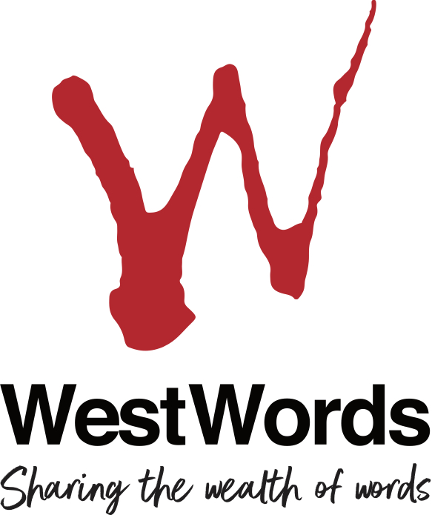

Copyright Agency/WestWords
Western Sydney Emerging Writers’ Fellowships

Application Form

WestWords Western Sydney Emerging Writers’ Fellowships 2019
Application form

Applications close 9am 4th November Decision advised late November 2019
Applicant details
Title: Mr Ms Mrs Other (specify)
Given name: Family name:
Postal Address:
Street/PO Box:
Suburb/Town: Post code:
Phone and email:
Tel (bh): ( ) (ah): ( )
Mob: Fax: ( )
Email (please print clearly):

1. Which genre best describes your project?
Children’s fiction General fiction
Young adult fiction Poetry
Non-fiction (adult readership) Non-fiction (child/young adult readership)
Writing for performance New media/online
Journalism Memoir/life writing
Graphic novels/comics Other illustrated/graphic work (eg zines)
Other (please describe in 100 words or less):

2. Fellowship project description
In separate attachment, please provide the following:
- Max. one (1) A4 page overview covering:
  - who you are, your age, your artform practice and your significant artistic milestones to date, noting any specific awards or recognition of outstanding achievement.
  - Your relationship to Western Sydney. (please refer to the “Who Should Apply” section of the information pack as a guide) Please note: if you are applying for exemption from the eligibility criteria: “have lived in Greater Western Sydney for more than 2 years” for reasons of being a recently arrived migrant/refugee, you will need to provide evidence of your status.
  - your interest in working with children and young adults.
- Max. two (2) A4 pages outlining:
  - the creative project you propose to undertake with this Fellowship
  - how the fellowship will support your development and/or practice as a writer/artist. (e.g. by providing time to write, support for research, purchase of materials - in the case of writers for multi-media, illustrators and designers).
  - what you hope to achieve in terms of your project during the period of your Fellowship.
- Max. one (1) A4 page outlining
  - your workshop project for working with children and/or young people. This could be as specific as who you would like to give the workshop to and where you would like undertake it, or simply an outline of the workshop and a list of aims you would hope to achieve.
NB: All attachments must be clearly marked on each page with your name and contact details.
3. Sample of your work
Please attach a sample of your work relevant to the project for which you are applying for this Fellowship. This may include:
- Maximum of 5 pages of your writing/illustrative work in the genre of your proposed Fellowship project. Work may come from published or unpublished work.
- Website or other multimedia (may be submitted as link or on a CD/DVD)

Web link:
Please contact WestWords for more information if you are unclear as to what work sample should be submitted.
NB: supplementary copies of published books or other works will not be accepted.
NB: All attachments must be clearly marked on each page with your name and contact details. Work samples will not be returned.
3. Referees
Please supply the names and contact details of 2 (two) referees who are familiar with your work and/or your interest in working with young people.
- Name:
Telephone:
Email:
Relationship :

2. Name:
Telephone:
Email:
Relationship :

(Please note the following section is primarily for statistical and reporting purposes and is not compulsory).
Demographic information
Do you identify as belonging to any of the following cultural/demographic groups?
i. Aboriginal or Torres Strait Islander Yes/No
ii. CALD (Culturally and linguistically diverse: do you identify as part of a cultural group other than Anglo-Australian): Yes/No
Please specify which cultural group/s you identify with:_______________________
___________________________________________________________________

iii. Do you speak a language other than English as a primary or secondary language? Yes/No
Please specify your primary or secondary language(s) other than English:
_____________________________________________________________
iv. Do you write in a language other than English? Yes/No
Please specify which language(s) other than English you write in:__________
___________________________________________________________________

How did you learn about the CA WestWords Western Sydney Emerging Writers’ Fellowships?

Declaration
I have read the guidelines relating to the CA WestWords Emerging Western Sydney Writers’ Fellowships. I certify that, to the best of my knowledge, the information contained in this application is correct. If my application is successful, I agree to abide by the conditions of the Fellowship as described in the Guidelines.

Signature: Date:
Send to:
WestWords
Emerging Western Sydney Writers’ Fellowships Applications
PO Box 2327
North Parramatta NSW 1750
or
email admin@westwords.com.au with
Emerging Writers’ Fellowships Application as your subject line.

